TABLEAU PORTFOLIO PROJECT

**KPI Dashboard for employees in a call center**

<!DOCTYPE HTML>

<!--

    Read Only by HTML5 UP

    html5up.net | @ajlkn

    Free for personal and commercial use under the CCA 3.0 license (html5up.net/license)

-->

<html>

    <head>

        <title>NYC buses Dashboard in Excel</title>

        <meta charset="utf-8" />

        <meta name="viewport" content="width=device-width, initial-scale=1, user-scalable=no" />

        <link rel="stylesheet" href="assets/css/main.css" />

    </head>

    <body class="is-preload">

        <!-- Header -->

            <section id="header">

                <header>

                    <span class="image avatar"><img src="images/avatar.jpg" alt="" /></span>

                    <h1 id="logo"><a href="#">Manasi Shidhaye</a></h1>

                    <p>Data Analyst<p><p/>

                    <p>Versed in Excel, Tableau and SQL</p><p/>

                    <p></p>

                    <ul class="icons">

                        <li><a href="#" class="icon brands fa-github"><span class="label">Github</span></a></li>

                        <li><a href="#" class="icon solid fa-envelope"><span class="label">Email</span></a></li>

                    </ul>

                </header>

                <nav id="nav">

                    <ul>

                        <li><a href="#Contact">Contact</a></li>

                    </ul>

                </nav>

            </section>

        <!-- Wrapper -->

            <div id="wrapper">

                <!-- Main -->

                    <div id="main">

                                    <div class="container">

                                    <p></p><a href="https://jacquelinealsi.github.io/" class="button">Back</a></p>

                                    <header class="major">

                                        <h3>NYC Buses Dashboard </h3></p>

                                    </header>

                                    <p><h4>Project Details:</h4>

                                        Explored NYC busess data to determine common delay or breakdown reasons, delay times as per companies as well as explored the correlation between specific days of the week and the frequency of breakdown or delays.</p>

                                    <p><img src="images/bike dashboard.jpg" alt="" width="800" height="400">

                                    <h4>Insights</h4>

                                        <ul class="sudo"><li>Majority of the bus breakdowns were due to mechanical problems.</li>

                                        <li>Regular servicing and maintainence can help save this problem.</li>

                                        <li>Buses were running late due to heavy traffic during peak times. </li>

                                        <li>A suggestion would be to pick up scchool students at non peak traffic times.</li>

                                        <li>COmpanies were sorted according to the highest delay times.</li>

                                        <li>A decline was found in the breakdowns as the week progressed from Monday towards Fridays.</li></ul>

                                    <p><h4>Data Source:</h4>

                                            This was a guided project as part of the Data Analyst Bootcamp.

                        <a href="https://github.com/AlexTheAnalyst/Excel-Tutorial/blob/main/Excel%20Project%20Dataset.xlsx" style="color: blue" target="_blank" </a>Excel-Tutorial</a></p>

                                </div>

                            </section>

                            <!-- Contact -->

                            <section id="Contact">

                                <div class="container">

                                    <h3>Contact Me</h3>

                                    <h4>Location</h4>

                                    <p>Austin, Tx</p>

                                    <h4>Email</h4>

                                    <p>manasishidhaye@gmail.com</p>

                                        </div>

                        <!-- Five -->

                        <!--

                            <section id="five">

                                <div class="container">

                                    <h3>Elements</h3>

                    </div>

                <!-- Footer -->

                    <section id="footer">

                        <div class="container">

                            <ul class="copyright">

                                <li>&copy; Untitled. All rights reserved.</li><li>Design: <a href="http://html5up.net">HTML5 UP</a></li>

                            </ul>

                        </div>

                    </section>

            </div>

        <!-- Scripts -->

            <script src="assets/js/jquery.min.js"></script>

            <script src="assets/js/jquery.scrollex.min.js"></script>

            <script src="assets/js/jquery.scrolly.min.js"></script>

            <script src="assets/js/browser.min.js"></script>

            <script src="assets/js/breakpoints.min.js"></script>

            <script src="assets/js/util.js"></script>

            <script src="assets/js/main.js"></script>

    </body>

</html>

**Introduction**

Hired as an Analytics Consultant by HCHC group to analyze their call center employees and provide data driven strategy to gain an understanding of the employee productivity.

This comprehensive analysis provides an in-depth understanding of the satisfaction rating, call volume during week , speed of answer, resolution rates and the resolved calls of all the employees in the call center. With a strategic roadmap in hand, HCHC group will be well-positioned to capitalize on the vast potential of their call center employees ensuring optimum productivity. 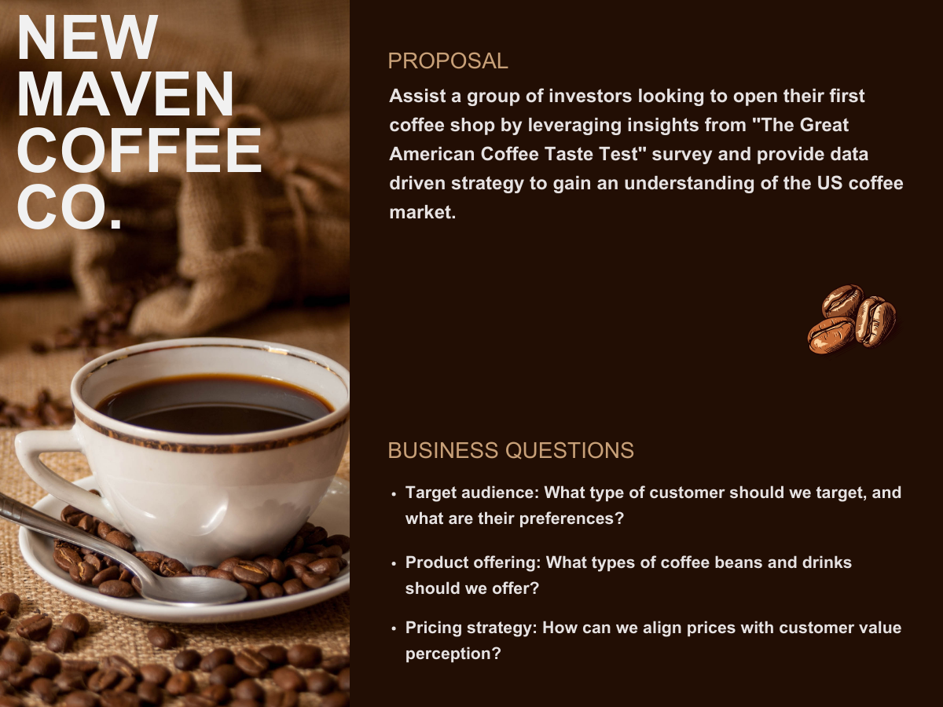

**To view the full interactive Tableau Dashboard click**[**<="" a="" style="box-sizing: inherit; margin: 0px; padding: 0px; border-width: 0px 0px 1px; border-top-style: initial; border-right-style: initial; border-bottom-style: solid; border-left-style: initial; border-top-color: initial; border-right-color: initial; border-bottom-color: rgb(228, 228, 228); border-left-color: initial; border-image: initial; font: inherit; vertical-align: baseline; transition: color 0.2s ease-in-out 0s, border-color 0.2s ease-in-out 0s; color: blue; text-decoration: none;">Here**](https://public.tableau.com/views/MavenCoffeeChallenge/Story1?:language=en-US&:sid=&:display_count=n&:origin=viz_share_link)

**Business Questions**

1. Target audience: What type of customer should we target, and what are their preferences?
2. Product offering: What types of coffee beans and drinks should we offer?
3. Pricing strategy: How can we align prices with customer value perception?

**About the Data**

Responses to "The Great American Coffee Taste Test" consisting of 4042 survey participants, various questions and a coffee taste test. The data contains 1 table consisting of 11 fields and 4043 records in csv format.

**Tools Used**

Excel (Data Cleaning)  
Tableau (Exploration & Visualization)

**Analysis**

Survey responses only from participants who typically drink their coffee at cafes were used to identify the "Ideal Customer" and their preferences. This is the type of customer we should target as they are more likely to frequent New Maven Coffee Co.

**Insights**

**Target Audience & Customer Preferences:**

Most participants feel that they are coffee connoisseurs and drink coffee because they like the taste, need the caffeine or out of ritual.

Although most participants drink coffee at home, when on the go they prefer to get their coffee either at a specialty cafe, a regular cafe or at one of the national coffee chains.

They also tend to drink 1-2 cups of black coffee per day.

**Coffee and Bean Preferences:**

Most participants prefer their coffee medium to somewhat strong and brewed from a light to medium roast bean.

The vote for fully caffeinated coffee was almost unanimous.

Coffee D was rated the best tasting coffee and was found by the participants to be more acidic than bitter.

**Consumer Preferences:**

Most participants spend between $20-$60 per month on coffee whether at home or at a cafe.

Most feel that money spent on coffee equipment is money well spent. But were split ~60/40 as to whether it was worth going to a cafe vs making their coffee at home.

Customers have paid between $6-$15 for coffee at a cafe in the past and are comfortable spending that much. Surprisingly, 20% of customers would spend over $20 at a cafe.

**Recommendations**

* Target the "Ideal Customer" (educated white male 25-34 y/o, works from home full time) who frequents cafes, knows good coffee and considers themselves somewhat of a coffee expert. With that in mind, a specialty cafe will likely do best.
* Offer light to medium roast caffeinated beans, which are more acidic than bitter and have fruity or chocolatey notes.
* The menu should include Pour Over, Latte, Cappuccino, Espresso and Regular drip coffee drinks brewed medium to somewhat strong.
* Offer whole milk, oat milk and half & half as those are most popular.
* Even though most prefer plain granulated sugar, raw sugar, artificial sweeteners and brown sugar should also be offered since most cafes offer them.
* To capture the at home coffee brewer (who may not think that money spent at a cafe is worth it) when they're “on the go” offer something that they can't get at home such as complex specialty drinks, exotic coffee beans and a great atmosphere/experience.
* To capture the at home coffee brewer (who may not think that money spent at a cafe is worth it) when they're “on the go” offer something that they can't get at home such as complex specialty drinks, exotic coffee beans and a great atmosphere/experience.

**Data Limitations**

* Since there was no data provided for flavorings, no recommendations can be given.
* Although the sample size was large at 4042 once filtered for 'participants who typically drink their coffee at a cafe' the sample size shrunk significantly.
* The data contains a significant number of NULL answers which were excluded for the purposes of this analysis.

**Data Source**

Maven Analytics [<="" a="" style="box-sizing: inherit; margin: 0px; padding: 0px; border-width: 0px 0px 1px; border-top-style: initial; border-right-style: initial; border-bottom-style: solid; border-left-style: initial; border-top-color: initial; border-right-color: initial; border-bottom-color: rgb(228, 228, 228); border-left-color: initial; border-image: initial; font-style: normal; font-variant-ligatures: normal; font-variant-caps: normal; font-variant-numeric: inherit; font-variant-east-asian: inherit; font-variant-alternates: inherit; font-variant-position: inherit; font-weight: 400; font-stretch: inherit; font-size: 17.3333px; line-height: inherit; font-family: Lato, sans-serif; font-optical-sizing: inherit; font-kerning: inherit; font-feature-settings: inherit; font-variation-settings: inherit; vertical-align: baseline; transition: color 0.2s ease-in-out 0s, border-color 0.2s ease-in-out 0s; color: blue; text-decoration: none; letter-spacing: normal; orphans: 2; text-align: start; text-indent: 0px; text-transform: none; widows: 2; word-spacing: 0px; -webkit-text-stroke-width: 0px; white-space: normal; background-color: rgb(255, 255, 255);">Great American Coffee Taste Test](https://mavenanalytics.io/challenges/maven-coffee-challenge/30)